**Project Design Phase-II**

**Technology Stack (Architecture & Stack)**

|  |  |
| --- | --- |
| Date | 16 October 2022 |
| Team ID | PNT2022TMID23106 |
| Project Name | Plasma Donor Application |
| Maximum Marks | 4 Marks |

**Technical Architecture:**

The Deliverable shall include the architectural diagram as below and the information as per the table1 & table 2

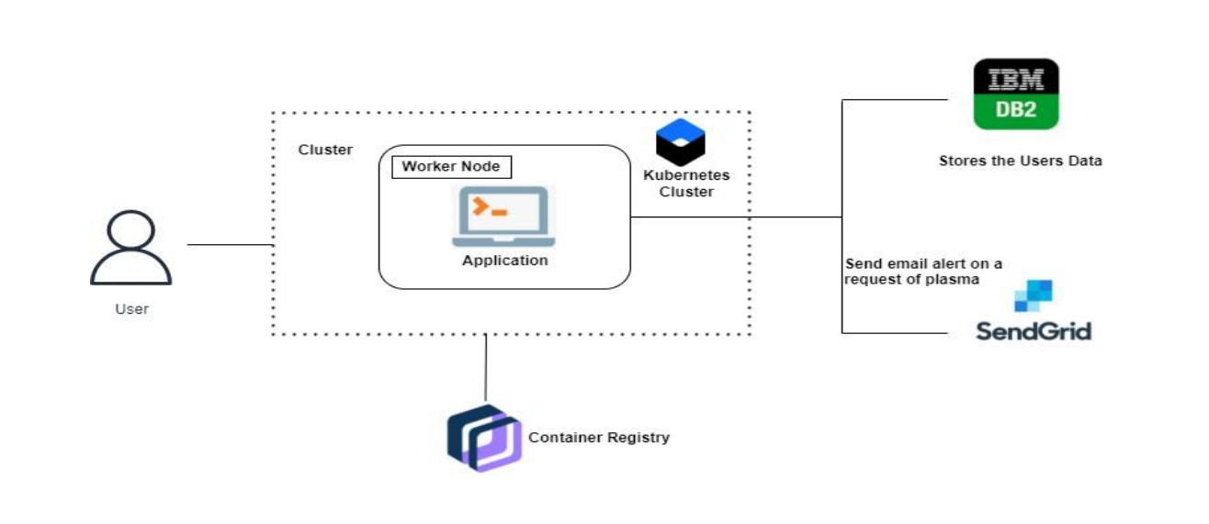

**Table-1 : Components & Technologies:**

|  |  |  |  |
| --- | --- | --- | --- |
| **S.No** | **Component** | **Description** | **Technology** |
|  | User Interface | The user can interact with our application with the help of Mobile app,Website. | HTML, CSS, JavaScript / Angular Js / React Js etc. |
|  | Application Logic-1 | The user can login with our application, but he/she should registered earlier in our web app. | Java / Python |
|  | Application Logic-2 | They can also register with the help of website. | IBM Watson STT service |
|  | Cloud Database | The user data will be stored and retrieved with help of this database. | IBM DB2, IBM Cloudant etc. |
|  | File Storage | The user documents like photos,records and much more will be stored in cloud bucket,etc.. | IBM Block Storage or Other Storage Service or Local Filesystem |
|  | External API | With the help of API,the user can search the profile  Based on their need. | IBM API, etc. |
|  | Infrastructure (Server / Cloud) | Application Deployment on Local System / Cloud. | Local, Cloud Foundry, Kubernetes, etc. |

**Table-2: Application Characteristics:**

| **S.No** | **Characteristics** | **Description** |
| --- | --- | --- |
|  | Is it scalable? | It follows highly scalable technologies that allows application to handle increase in large user data’s and workload. |
|  | Is it modifyable? | It is highly modifyable and maintenance requires low cost,compared to other application. |
|  | Is the System Robust? | It does not disturb the performance of the computer by not affecting the operating system.It works in minimal hardware systems. |